**BeautyDessert.com**

(Alpha 0.4)

Specification Document version 0.3

|  |  |  |  |
| --- | --- | --- | --- |
| **Version** | **Date** | **Descriptions** | **Name** |
| 0.1 | 30 – 01 – 2016 | First Draft | Amit |
| 0.2 | 20 – 03 – 2016 | Design Specification 1 | Amit |
| 0.3 | 02 – 04 – 2016 | Design Specification 2 | Amit |
| 0.4 | 13 – 05 – 2016 | Test Report | Nook (Tester) |

GitHub Link = https://github.com/amitnopanan/ProjectSE

**DESCRIPTION COMPONENT 1. A detailed description of each software component contained within the architecture is presented. :**

**Product Management**

1.2.1. PROCESSING NARRATIVE (PSPEC) FOR COMPONENT 1. It should also describe the responsibilities of the component.

- Product Management is a component for manage Product’s information that show in web page. . There’re operations to add new product, edit information from existing product and delete existing product.

1.2.2. COMPONENT 1 PROCESSING DETAIL. A detailed algorithmic description for each component is presented.

1.2.2.1. Design Class hierarchy for component 2

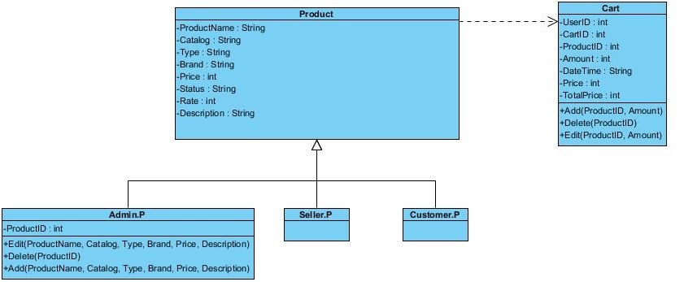

**Figure 4.2.2.1**

1.2.2.2. Restrictions/limitations for component 2

- Product management is limitation for every customer and seller to see product’s information. In the other hand administration can add, edit and delete product data.

1.2.2.3. Performance issues for component 2

- All data must match the data that input by administration.

- All product data and picture must be shown within 3 seconds.

- All data that be added must finish within 3 seconds.

- All editing data must be finish within 3 seconds.

- Pop-up for success and error must be shown within 3 seconds.

1.2.2.4. Design constraints for component 2

- Use PHP, HTML language.

- Catalog are fixed to be skin care, cosmetic or dietary supplement.

- Type are fixed depend on catalog.

- ProductID is automatically generated.

- Status and rate is change depend on number of product that has been sold.

- ProductName, Catalog, Type, Brand and Price are required fields.

- Must have edit operation in every field of data except ProductID and Rate.

- Only Administration can use add, edit and delete operation.

1.2.2.5. Processing detail for each operation of component n

1.2.2.5.1. Processing narrative (PSPEC) for each operation

- Add (ProductName, Price, Quantity, ProductType, ProductImage) is operation to add new product to database.

- Edit (ProductName, Price, Quantity, ProductType, ProductImage) is operation to edit existing product data.

- Delete (ProductID) is operation to delete all data of existing product.

1.2.2.5.2. Algorithmic model (e.g., PDL) for each operation

- Add (ProductName, Catalog, Type, Brand, Price, Description)

Start

If ProductID is not exist

Create new Product

Return TRUE

Else

Return FALSE

End

- Edit (ProductName, Catalog, Type, Brand, Price, Description)

Start

If ProductID is exist

Check for field to edit

Replace text field

Return TRUE

Else

Return FALSE

End

- Delete (ProductID)

Start

If ProductID is exist

Delete all field of ProductID

Return TRUE

Else

Return FALSE

End.

**Source Code**

**View Product**

*admin_products.php*

<?php

//connect to Locolhost And Data base “Projectse”

$conn = new mysqli("127.0.0.1", "root", "", "projectse");

//show error massage if connect fails

if (mysqli_connect_errno())

{

echo "Failed to connect to MySQL: " .mysqli_connect_error();

}

// select all of product from ‘product’ table in ‘projectse’ database

$sql = "SELECT product.*

FROM product";

$query = mysqli_query($conn,$sql) or die ("Error Query [".$sql."]");

$count = 0;

?>

<div class="row">

<div class="col-xl-4 col-lg-12">

<table class="table table-bordered table-hover table-striped">

<thead>

<tr>

<th>ProductID</th>

<th ><center>ProductName</center></th>

<th>Price</th>

<th>Quantity</th>

<th>Product Type</th>

<th>Photo</th>

<th>Commenet</th>

<th><center>Edit</center></th>

<th>Delete</th>

</tr>

</thead>

<tbody>

<?php

//fetch result we select from database

while($result = mysqli_fetch_array($query))

{

echo "<td>".$result["ProductID"]."</td>";

echo "<td>".$result["ProductName"]."</td>";

echo "<td>".$result["Price"]."</td>";

echo "<td>".$result["Quantity"]."</td>";

echo "<td>".$result["ProductType"]."</td>";

?>

<td><img src="<?php echo $result["PictureURL"];?>" alt="" height="42" width="42" /><td>

<?php

echo "<td><a href='admin_editproducts.php?ProductID=".$result['ProductID']."'> Edit </a></td>";

echo "<td><a href='admin_deleteproducts.php?ProductID=".$result['ProductID']."'> Delete </a></td><tr>";

?>

<?php

echo"</form>";

} ?>

</tbody>

</table>

//close database

<?php mysqli_close($conn); ?>

**Add Product**

*admin_addproducts.html*

//Post method to admin_addproducts.php to add products

<form action="admin_addproducts.php" method = "post" >

<form onsubmit="return false">

//User input Product Name, type is text If not input will show error massage

Product Name: <br><input type="text", required autocomplete="on" name="ProductName"><br>

//User input Product Price, type is number, If not input will show error massage

Price:<br><input type="number" required autocomplete="on" name="Price"><br>

//User input Quantity of Product; type is number, If not input will show error massage

Quantity:<br><input type="number" required autocomplete="on" name="Quantity"> <br>

//User select Product Type from the list below

Product Type:<br>

<select name="ProductType" required autocomplete="on">

<option value="ProductType" selected>-------Product Type-------</option>

<option value="Cosmetics_Faces">Cosmetics Faces</option>

<option value="Cosmetics_Eye&EyeBrow">Cosmetics Eye&EyeBrow</option>

<option value="Cosmetics_Lips&Cheek">Cosmetics Lips&Cheek</option>

<option value="Skincare_Lotion&Emulsion">Skincare Lotion&Emulsion</option>

<option value="Skincare_Cream">Skincare Cream</option>

<option value="DietarySupplement">DietarySupplement</option>

</select><br>

//User input Product Picture URL, type is URL, If not input or input not URL will show error massage

Picture URL:<br><input type="url" required autocomplete="on" name="PictureURL"> <br>

//click to add product , will use post method send data to admin_products.php

<button class="submitbtn">Add</button>

</form>

</form>

*admin_addproducts.php*

<?php

//connect to local host and database ‘projectse’

$con=mysqli_connect("127.0.0.1","root","","projectse");

//show error massage if cannot connect

if (mysqli_connect_errno()){echo "Failed to connect to MySQL: " . mysqli_connect_error();}

//get value from post method from admin_addproduct.html and give value in from of $NameofAttibute

$ProductName= mysqli_real_escape_string($con, $_POST['ProductName']);

$Price = mysqli_real_escape_string($con, $_POST['Price']);

$Quantity= mysqli_real_escape_string($con, $_POST['Quantity']);

$ProductType= mysqli_real_escape_string($con, $_POST['ProductType']);

$PictureURL= mysqli_real_escape_string($con, $_POST['PictureURL']);

//Insert value into table product

$sql = "INSERT INTO product (ProductName, Price, Quantity, ProductType, PictureURL)

VALUES ('".$ProductName."', '".$Price."','".$Quantity."','".$ProductType."', '".$PictureURL."');";

if (!mysqli_query($con,$sql)) {

die('Error: ' . mysqli_error($con));

}

Print out add value to database already then go to admin_products.php

echo "The data has been added into the database.";

mysqli_close($con);

//after add done go to admin_products.php

header("location:admin_products.php");

?>

**Edit Product**

*admin_editproducts.php*

<?php

//get product ID from ProductID that we select from admin_products.php

if(isset($_GET['ProductID']))

{

$ProductID=$_GET['ProductID'];

if(isset($_POST['submit']))

{

$ProductName=$_POST['ProductName'];

$Price=$_POST['Price'];

$Quantity=$_POST['Quantity'];

$ProductType=$_POST['ProductType'];

$PictureURL=$_POST['PictureURL'];

//Use sql to update values in to product table

$query3=mysql_query("UPDATE product SET ProductName='$ProductName', Price='$Price', Quantity='$Quantity', ProductType='$ProductType', PictureURL='$PictureURL' WHERE ProductID='$ProductID'");

if($query3)

{

//Print Out Update done! And provide like to go back to Product page(admin_products.php)

echo 'Update Done! ';

echo '<a href= "admin_products.php"> Back to Product Page</a>';

}

}

$query1=mysql_query("select * from product where ProductID='$ProductID'");

$query2=mysql_fetch_array($query1);

?>

<form method="post" action="">

//in every box will show the date of it which is user can see and edit but if user delete in the data and didn’t put any data or put the wrong type of data it will show error

Product Name: <br><input type="text" required autocomplete="on" name="ProductName" value="<?php echo $query2['ProductName'] ?>"><br>

Price:<br><input type="number" name="Price" value="<?php echo $query2['Price'] ?>"><br>

Quantity:<br><input type="number" required autocomplete="on" name="Quantity" value="<?php echo $query2['Quantity'] ?>"> <br>

Product Type:<br>

<select name="ProductType" >

<option value="<?php echo $query2['ProductType'] ?>" >-------Product Type-------</option>

<option value="Cosmetics_Faces">Cosmetics Faces</option>

<option value="Cosmetics_Eye&EyeBrow">Cosmetics Eye&EyeBrow</option>

<option value="Cosmetics_Lips&Cheek">Cosmetics Lips&Cheek</option>

<option value="Skincare_Lotion&Emulsion">Skincare Lotion&Emulsion</option>

<option value="Skincare_Cream">Skincare Cream</option>

<option value="DietarySupplement">DietarySupplement</option>

</select><br>

Picture URL:<br><input type="url" required autocomplete="on" name="PictureURL" value="<?php echo $query2['PictureURL'] ?>"> <br>

//this button use if user want to recover the data that they change but didn’t update yet

<button class="submitbtn">Recover</button>

//this button use to update data into database

<input type="submit" name="submit" value="update" />

</form>

<?php

}

?>

**Delete Product**

*admin_deleteproducts.php*

<?php

//get product ID from ProductID that we select from admin_products.php

if(isset($_GET['ProductID']))

{

$ProductID=$_GET['ProductID'];

//delete product where ProductID = ProductID that we selected

$query1=mysql_query("DELETE FROM product WHERE ProductID='$ProductID'");

if($query1)

{

//after done with delete go back to admin_products.php

header('location:admin_products.php');

}

}

?>

**Test Flow**

I WANT TO PERFORM ACTIONS AND SEE RESULT  
  
//check current page  
I am on page '/Non_Login.html'  
I wait "2"  
//fill username(Email) and password  
I fill field 'Email'," 'amit2506@hotmail.com'  
I fill field 'Password'," "amit2506""  
//click sign in button  
I click '/html/body/div[2]/section[3]/div/div[1]/form/fieldset/div[3]/input'  
I wait "2"  
//click on product tab  
I click '/html/body/div/nav/div[2]/ul/li[2]/a'  
//click add product   
I click '/html/body/div/div/div/div[2]/a'  
//fill product information  
I fill field 'ProductName'," 'Creamy'  
I fill field 'Price'," '100'  
I fill field 'Quantity'," '1'  
I select option 'ProductType'," 'Skincare_Cream'  
I fill field 'PictureURL'," '[http://www.girlsallaround.com/wp-content/uploads/2015/02/whipped-cream.jpg](http://l.facebook.com/l.php?u=http%3A%2F%2Fwww.girlsallaround.com%2Fwp-content%2Fuploads%2F2015%2F02%2Fwhipped-cream.jpg&h=eAQF2mUPz)'  
//click add button  
I click '/html/body/div/div/div/div[2]/div/div/div/div/form/button'  
I wait "3"  
//click edit button  
I click '/html/body/div/div/div/div[3]/div/table/tbody/tr[11]/td[8]/a'  
//edit information (Change product's quantity from 1 to 5)  
I fill field 'Quantity'," '5'  
//click update  
I click '/html/body/div/div/div/form/input[5]'  
//go back to product list  
I click '/html/body/div/div/div/a'  
I wait "3"  
  
//click delete button  
I click '/html/body/div/div/div/div[3]/div/table/tbody/tr[11]/td[9]/a'  
I wait "3"  
//click add product  
I click '/html/body/div/div/div/div[2]/a'  
//fill product information  
I fill field 'ProductName'," 'EyeSkadow'  
I fill field 'Price'," '250'  
I fill field 'Quantity'," '2'  
I select option 'ProductType'," 'Cosmetics_Eye&EyeBrow'  
//click add button  
I click '/html/body/div/div/div/div[2]/div/div/div/div/form/button'  
I wait "3"

**Test case Table**

|  |  |  |  |  |  |  |  |  |
| --- | --- | --- | --- | --- | --- | --- | --- | --- |
| **Test ID** | **Test Description** | **Test Data** | **Step** | **Precondition** | **Post condition** | **Expected Result** | **Actual Result** | **Status** |
| 1 | User can login if he enters the correct  E-mail and Password | **E-Mail:**  Amit2506@hotmail.com  **Password:**  Amit2506 | 1.Open webpage  2. Go to login page  3. Enter Amit2506@hotmail.com for E-mail  4. Enter Amit2506 for Password  5. Click ‘Login’ | User Account must exist in the database | Check user type = Admin | Webpage direct to admin page. The Email is show on the top right menu | Webpage direct to admin page. The Email is show on the top right menu | PASS |
| 2 | User can login if he enters the correct  E-mail and Password | **E-Mail:**  iigd@hotmail.co.th  **Password:**  Prae1812 | 1.Open webpage  2. Go to login page  3. Enter iigd@hotmail.co.th for E-mail  4. Enter Prae1812 for Password  5. Click ‘Login’ | User Account must exist in the database | Check user type = Customer | Webpage direct to home page. The Email is show on the top right menu | Webpage direct to home page. The Email is show on the top right menu | PASS |
| 3 | User cannot login if he doesn't enter  E-mail or Password  (Customer) | **E-Mail:**  iigd@hotmail.co.th  **Password:**  --none--- | 1.Open webpage  2. Go to login page  3. Enter iigd@hotmail.co.th for E-mail  4. Click ‘Login’ | User Account must exist in the database  (Customer) | None | The login form displays the error message and prevents user from logging in. And show message error | The login form displays the error message and prevents user from logging in but does not show message error | FAIL |
| 4 | User cannot login if he doesn't enter  E-mail or Password  (Admin) | **E-Mail:**  Amit2506@hotmail.com  **Password:**  --none--- | 1.Open webpage  2. Go to login page  3. Enter Amit2504@hotmail.com for E-mail  4. Click ‘Login’ | User Account must exist in the database  (Admin) | None | The login form displays the error message and prevents user from logging in. And show message error | The login form displays the error message and prevents user from logging in but does not show message error | FAIL |
| 5 | Normal adding new product | **ProductName:** test  **Price:** 12  **Quantity:** 10  **ProductType:** testtype  **Picture URL: http://www.xxxxx.com** | 1. Login as Admin  2. Click on tab Product in the left menu bar  3. Fill Product’s Name  4. Fill Product’s Price  5. Fill Product’s quantity  6. Fill Product’s type  7. Fill Product’s url  8. Click ‘Add Product’ | User account must be admin and exist in the database | Product added is existing in database | Adding product Successful and product show in the product inventory | Add product Successful and product show in the product inventory | PASS |
| 6 | Add Product without any data | **ProductName:** -None-  **Price:** --None--**Quantity:** --None--  **ProductType:** --None--  **Picture URL:** --None-- | 1. Login as Admin  2. Click on tab Product in the left menu bar  3. Click ‘Add Product’ | User account must be admin and exist in the database | None | Adding Product unsuccessful and stay in adding page | Adding Product unsuccessful and stay in adding page | PASS |
| 7 | Adding Product with insufficient data | **ProductName:** test  **Price:** 12  **Quantity:** 10  **ProductType:** --None--  **Picture URL:** --None-- | 1. Login as Admin  2. Click on tab Product in the left menu bar  3. Fill Product’s Name  4. Fill Product’s Price  5. Fill Product’s quantity  8. Click ‘Add Product’ | User account must be admin and exist in the database | None | Adding Product unsuccessful and stay in adding page | Adding Product unsuccessful and stay in adding page | PASS |
| 8 | Add Product that the name already exists in database | **ProductName:** test  **Price:** 12  **Quantity:** 10  **ProductType:** testtype  **Picture URL: http://www.xxxxx.com** | 1. Login as Admin  2. Click on tab Product in the left menu bar  3. Fill Product’s Name  4. Fill Product’s Price  5. Fill Product’s quantity  6. Fill Product’s type  7. Fill Product’s url  8. Click ‘Add Product’ | 1.User account must be admin and exist in the database  2.Product must exist in the database | None | Adding Product unsuccessful and stay in adding page. And show the error message that the ‘Product is already in’ | Adding Product unsuccessful and stay in adding page.  Does not show error message that the ‘Product is already in’ | FAIL |
| 9 | Add Product with wrong type | **ProductName:** test  **Price:** 12  **Quantity:** 10  **ProductType:** testtype  **Picture URL:** 12345.jpg | 1. Login as Admin  2. Click on tab Product in the left menu bar  3. Fill Product’s Name  4. Fill Product’s Price  5. Fill Product’s quantity  6. Fill Product’s type  7. Fill Product’s url with wrong type  8. Click ‘Add Product’ | 1.User account must be admin and exist in the database  2.Product must exist in the database | None | Adding Product unsuccessful and stay in adding page. And show the error message that the ‘Wrong type with url’ | Adding Product unsuccessful and stay in adding page. And show the error message that the ‘Wrong type with url’ | PASS |
| 10 | Normal Editing Product | **ProductName:** test **1**  **Price:** 10  **Quantity:** 15  **ProductType:** testtype  **Picture URL: http://www.xxxxx.com** | 1. Login as Admin  2. Click on tab Product in the left menu bar  3. Click ‘Edit’ the product that you want to edit  4. Fill Product’s Name  5. Fill Product’s Price  6. Fill Product’s quantity  7. Fill Product’s type  8. Click ‘Update’ | 1.User account must be admin and exist in the database  2.Product must exist in the database | Product that edit is existing in database (inventory) | Editing product Successful and product show in the product inventory | Editing product Successful and product direct show in the product inventory | PASS |
| 11 | Editing Product without any data | **ProductName:** -None-  **Price:** -None-  **Quantity:** --None--  **ProductType:** --None--  **Picture URL:** --None-- | 1. Login as Admin  2. Click on tab Product in the left menu bar  3. Click ‘Edit’ the product that you want to edit  4. Delete Product’s Name  5. Delete Product’s Price  6. Delete Product’s quantity  7. Delete Product’s type  8. Delete Product’s Picture url  9. Click ‘Update’ | 1.User account must be admin and exist in the database  2.Product must exist in the database | None | Editing product unsuccessful and product does not show in the product inventory and show the error message ‘Please field the form’ | Editing product unsuccessful and product does not show in the product inventory and show the error message ‘Please field the form’ | PASS |
| 12 | Delete Product from inventory | None | 1. Login as Admin  2. Click on tab Product in the left menu bar  3. Click ‘Delete’ product that you want to delete | 1.User account must be admin and exist in the database  2.Product must exist in the database | Product that delete is not existing in database (inventory) | Product delete from inventory | Product delete from inventory | PASS |

**Test Result**

**Case1:** Admin Login with email and password Successful

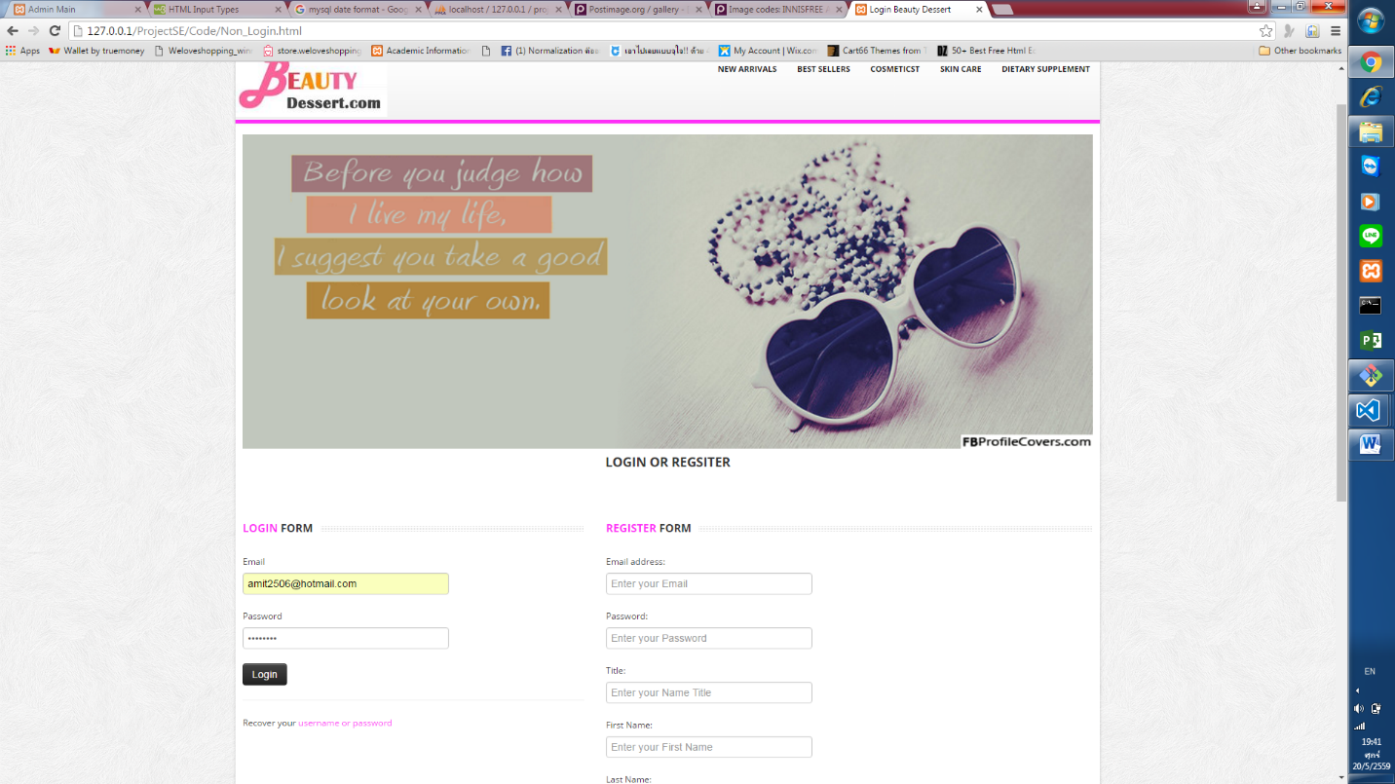

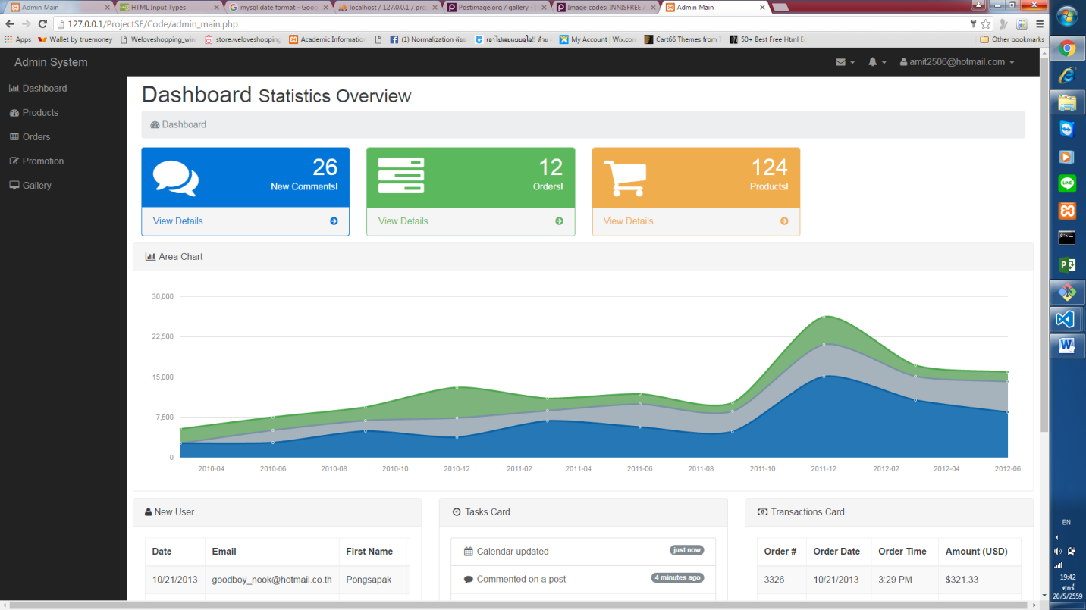

**Case2:** Customer Login with Email and Password Successful

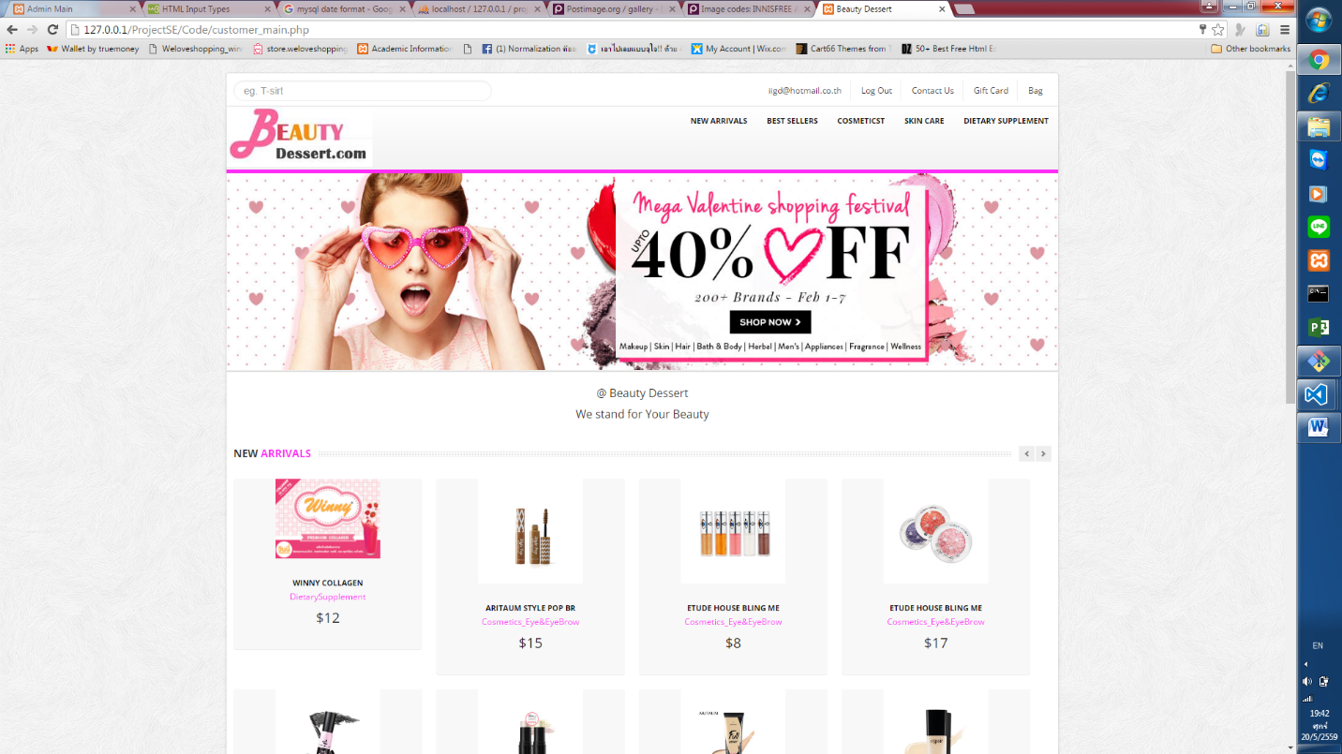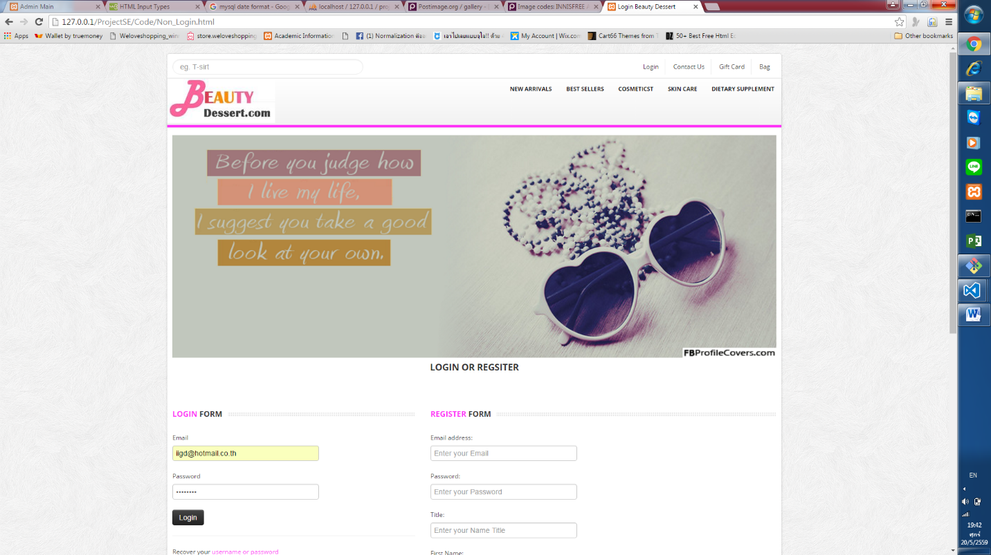

**Case3:** Customer input only Email and Customer input only Password

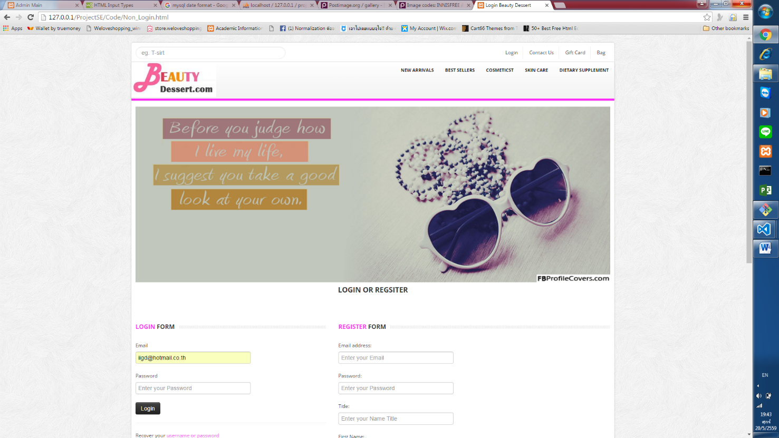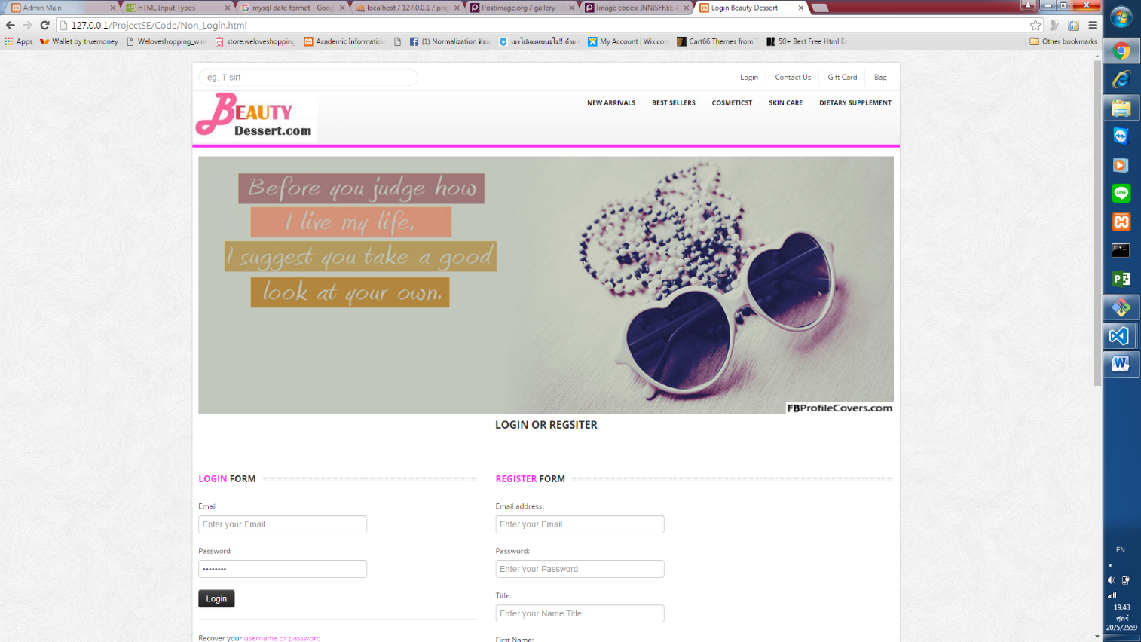

Un-Successful – Reload Login Page

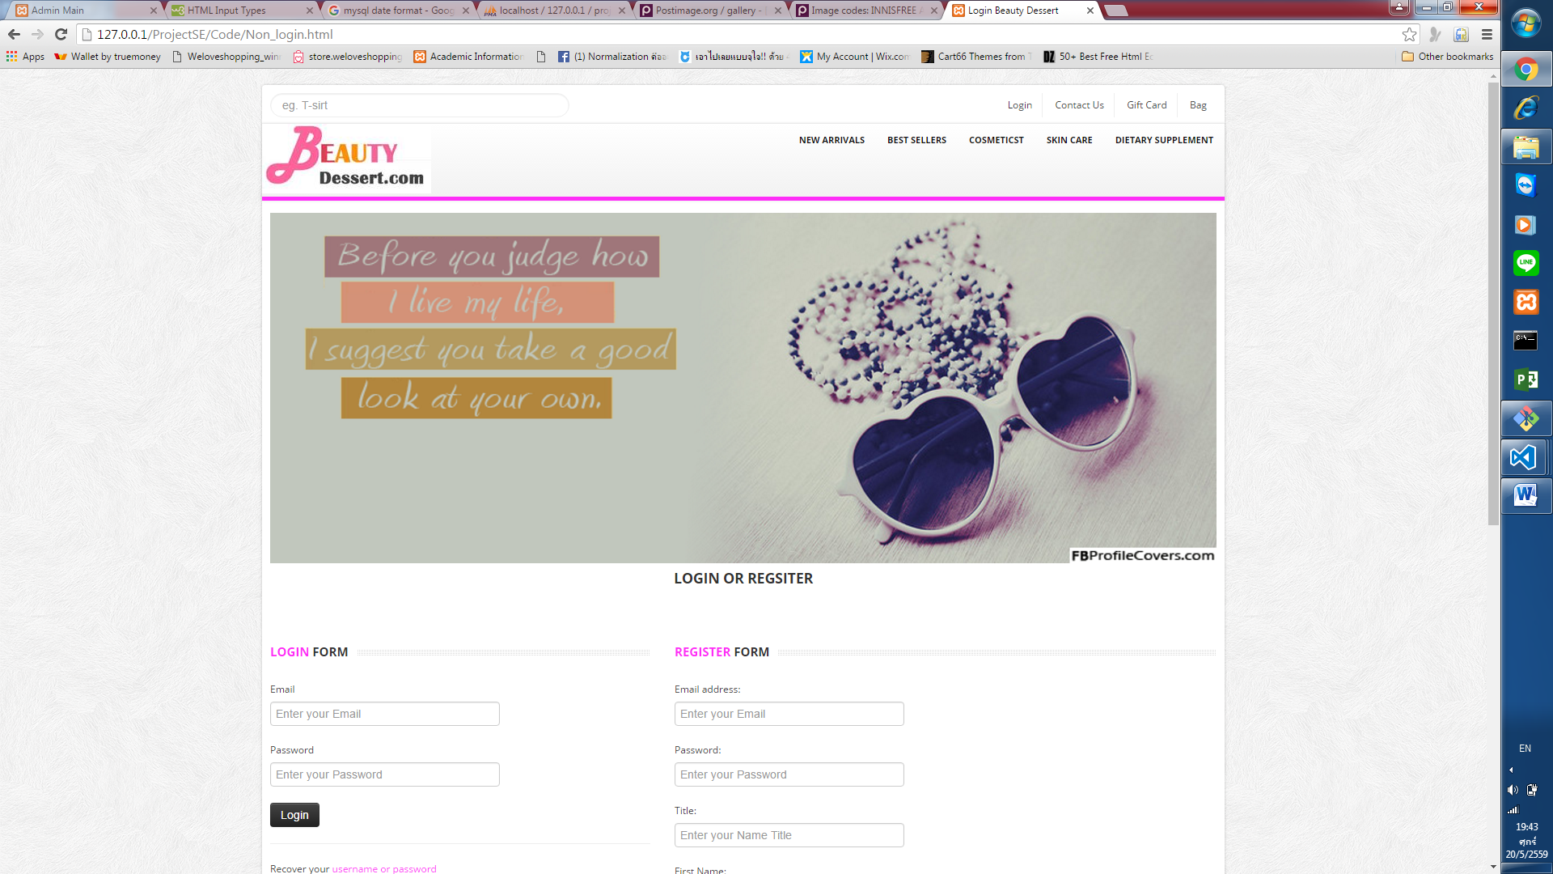

**Case4:** Admin input only Email and Admin input only Password

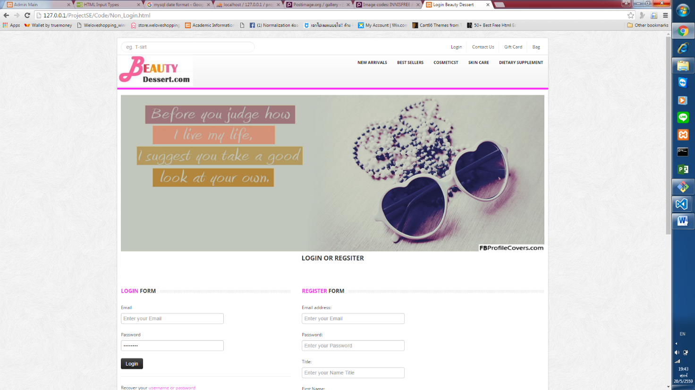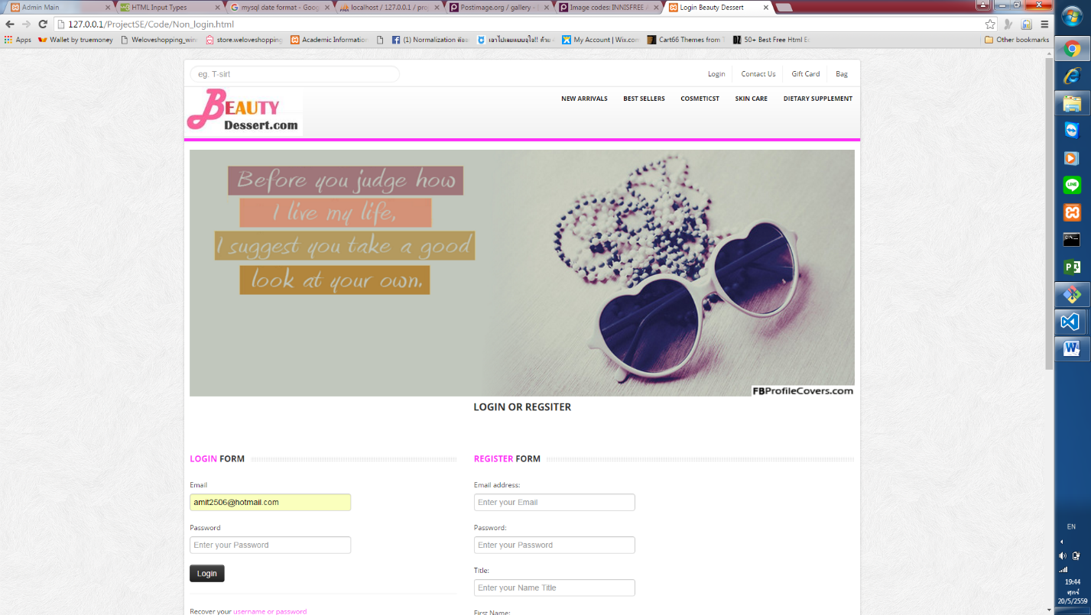

Un-successful – Reload Login Page



**Case5:** Add Product ‘Missha Eye Colour ’ and then Show in Product View

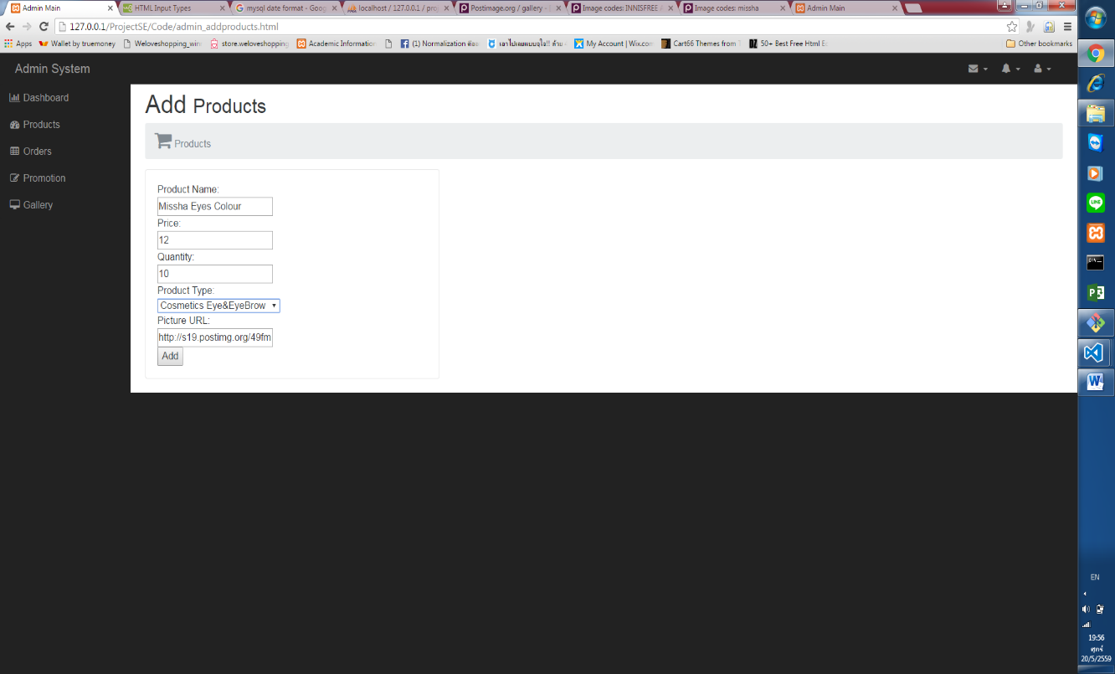

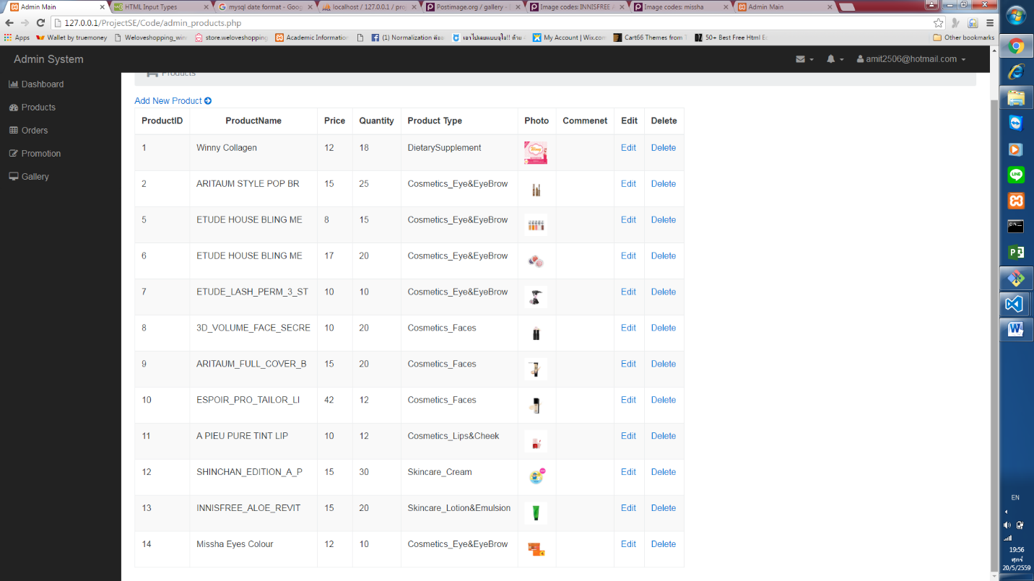

**Case6:** Cannot Add product without filling information

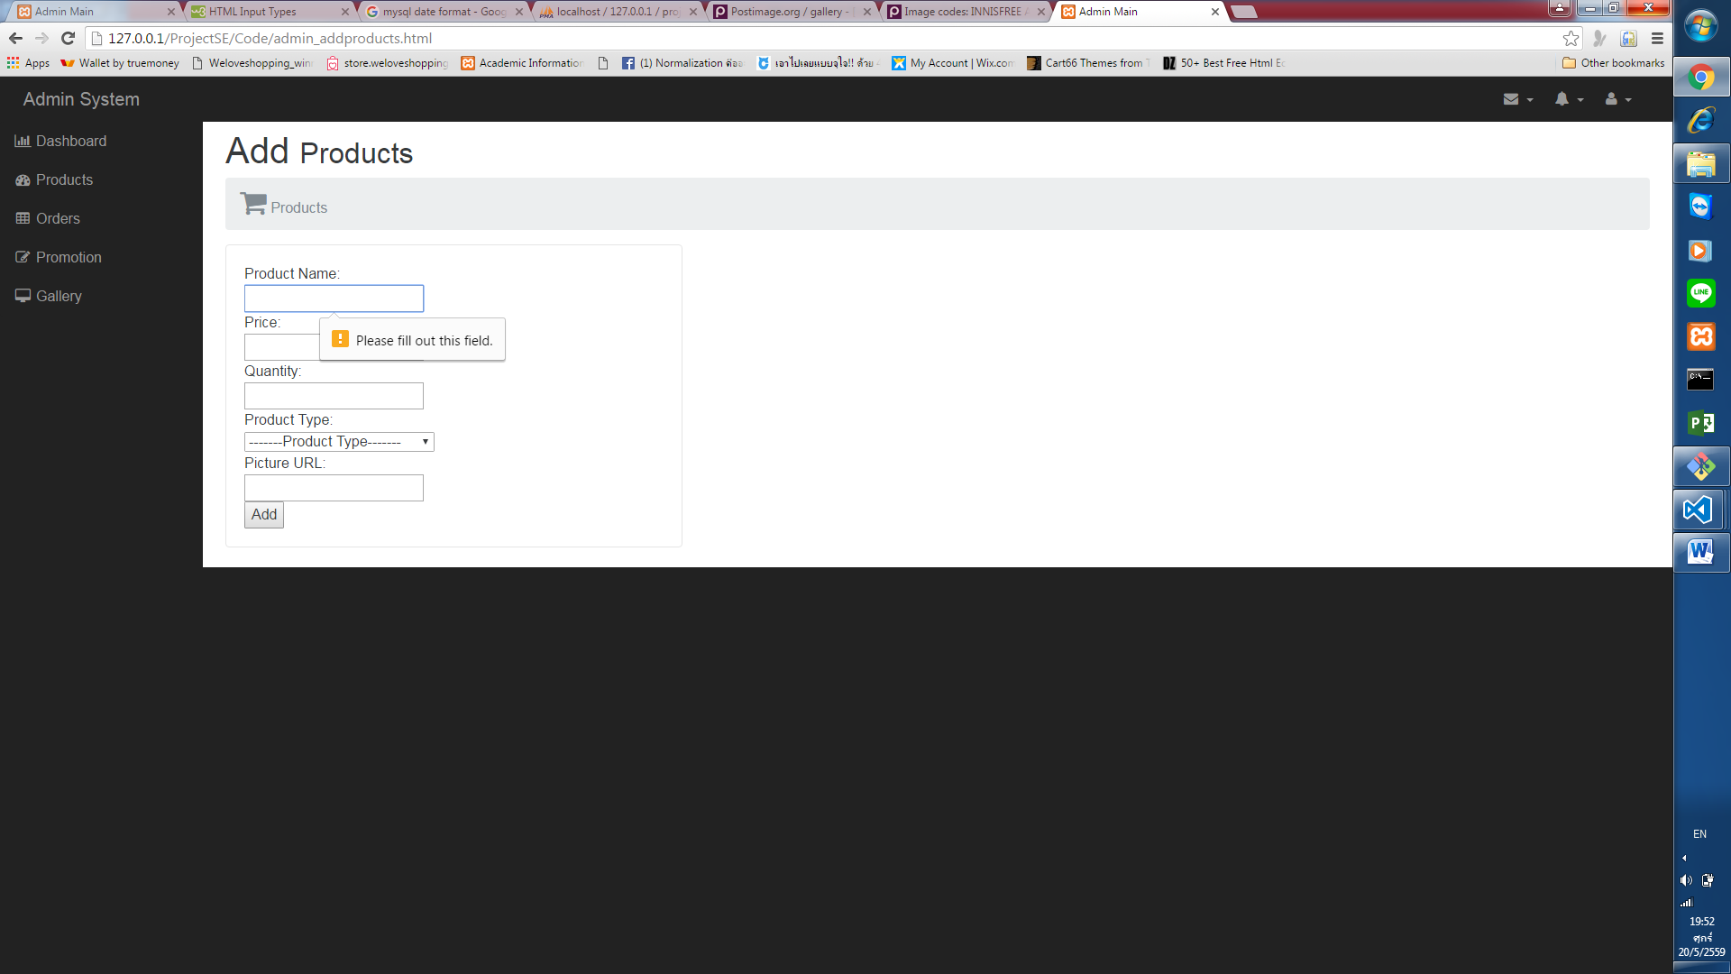

**Case7:** Doesn’t Fill all Filed

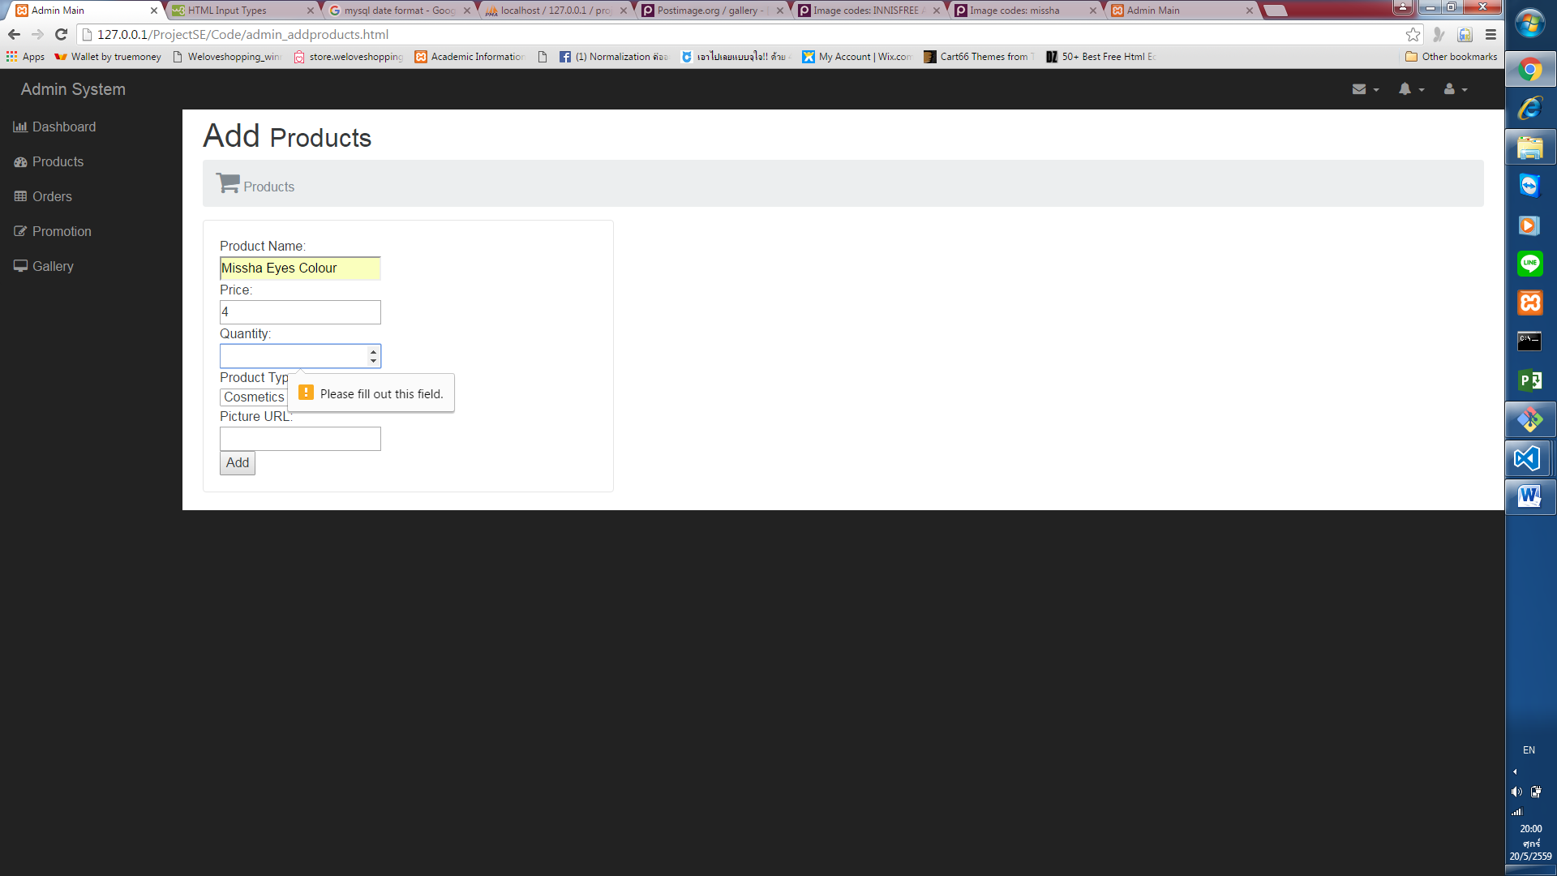

**Case8:** Add Product that the name already exists in database

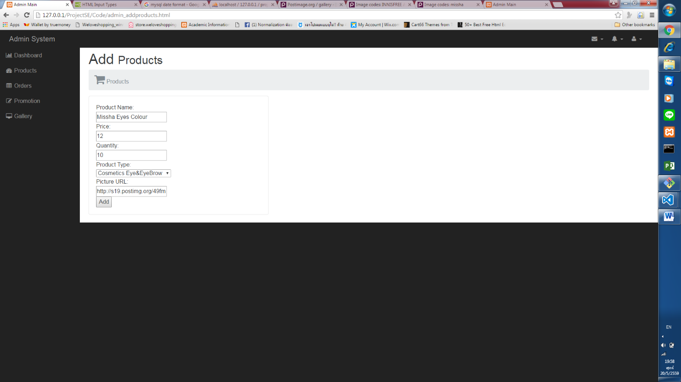In this pic - Add Product ‘Missha Eyes Colour’ Again

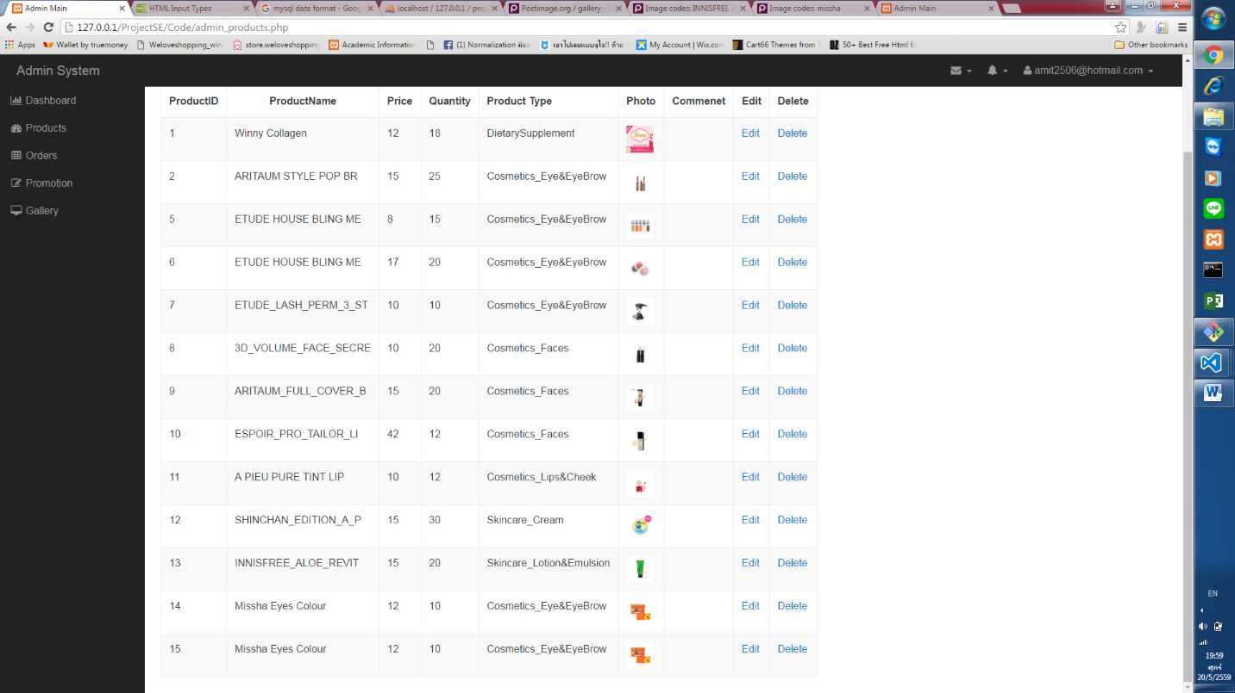

**Case9:** In Picture URL user much input in URL forms

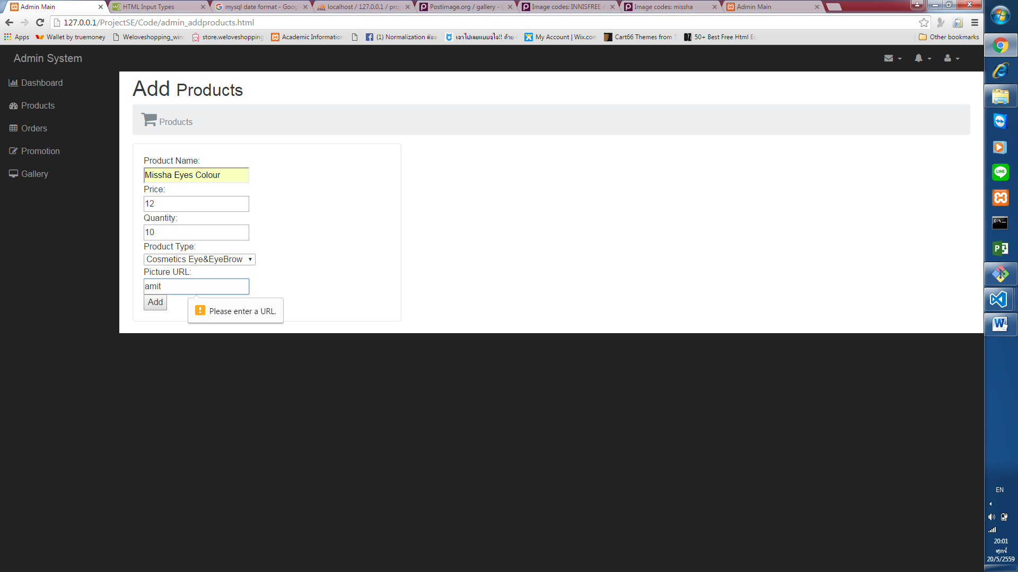

**Case10:** Edit Product

-Edit ‘Missha Eyes Colour ’

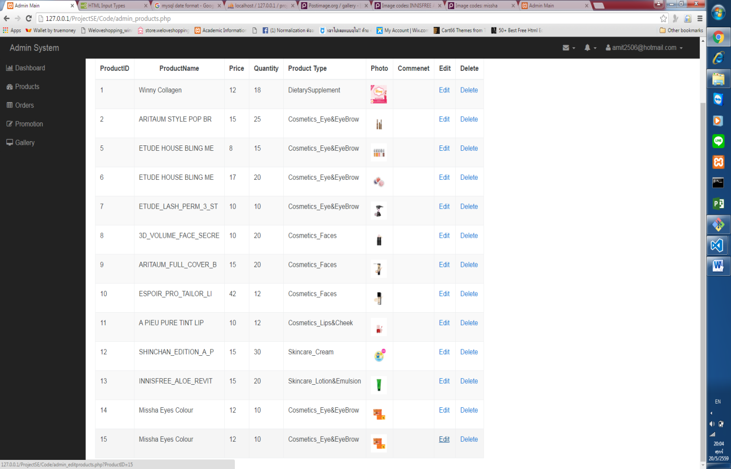

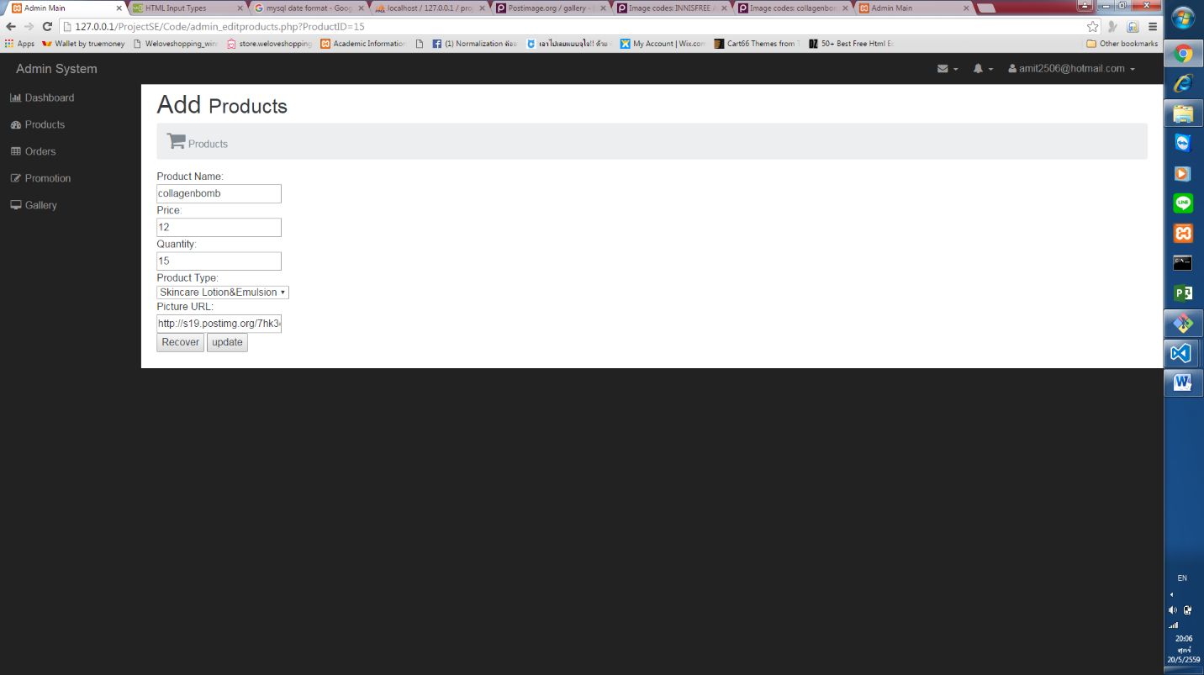

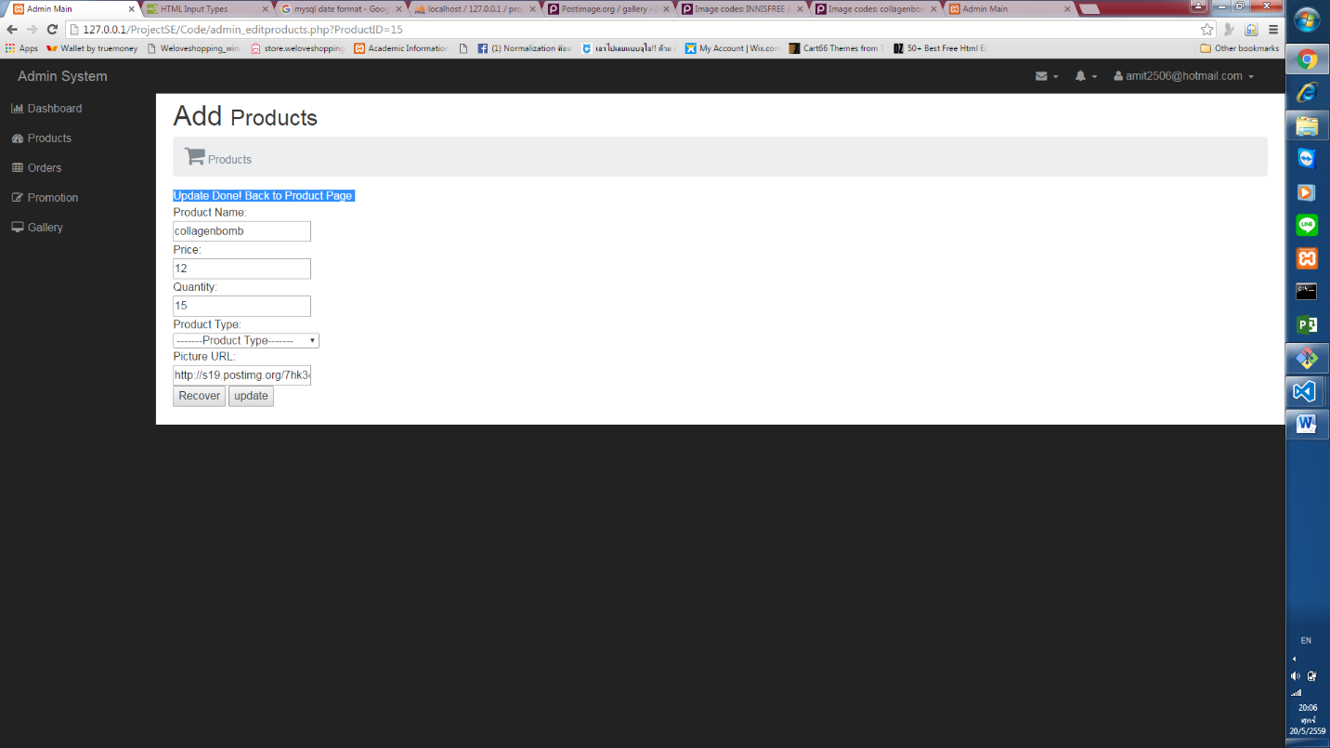

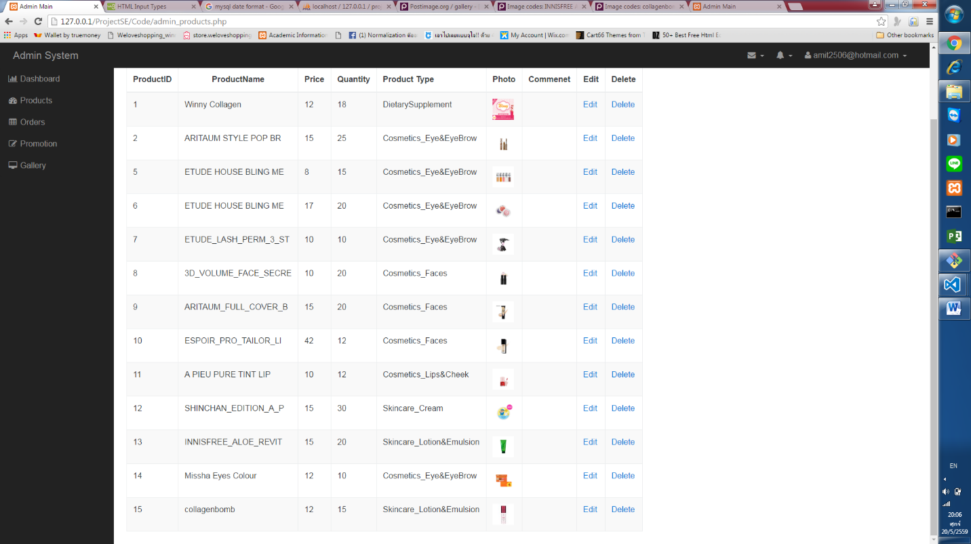

**Case11:** Editing Product without any data

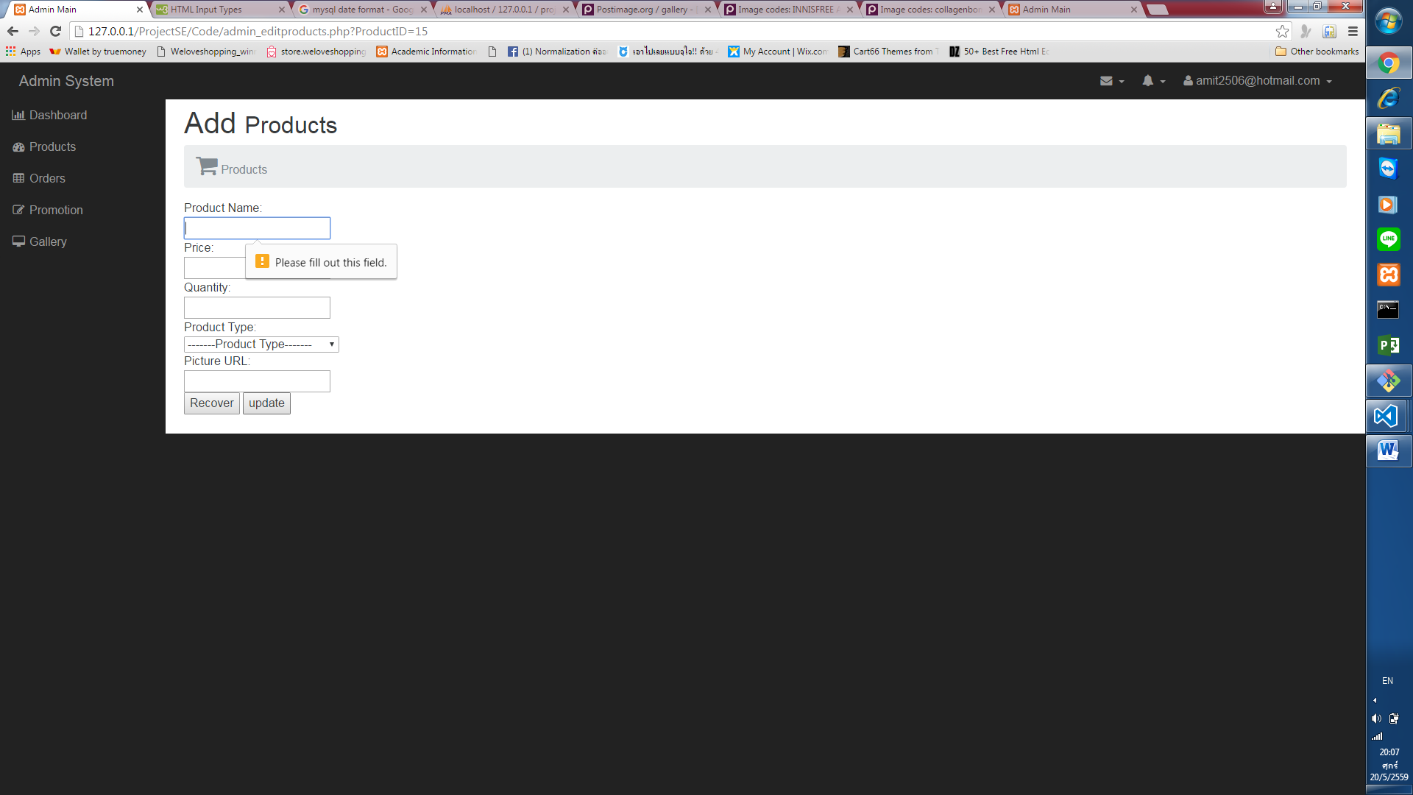

**Case12:** Delete Product from inventory

